**Java OOPS**

1. Create a class called "Person" with attributes "name" and "age". Also create a constructor and getter methods for the attributes.

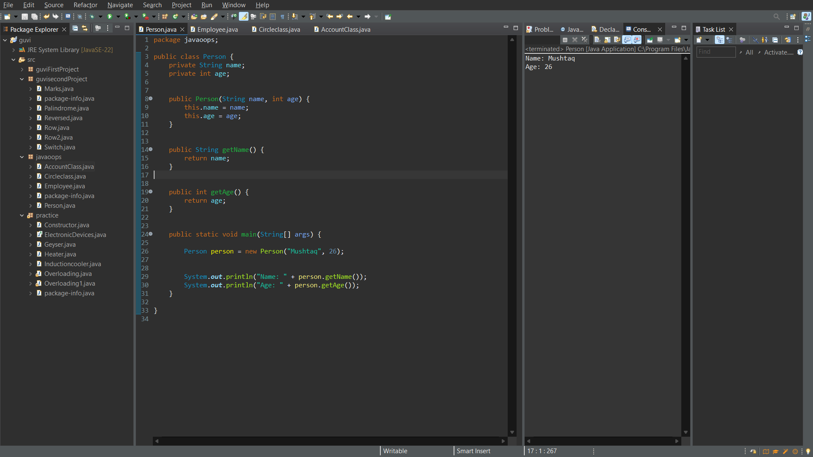

2. Create an implementation for a java class named Employee that represents an employee with attributes including ID, name, and salary. The class includes a method called raiseSalary (percent), which updates the salary by a specified percentage

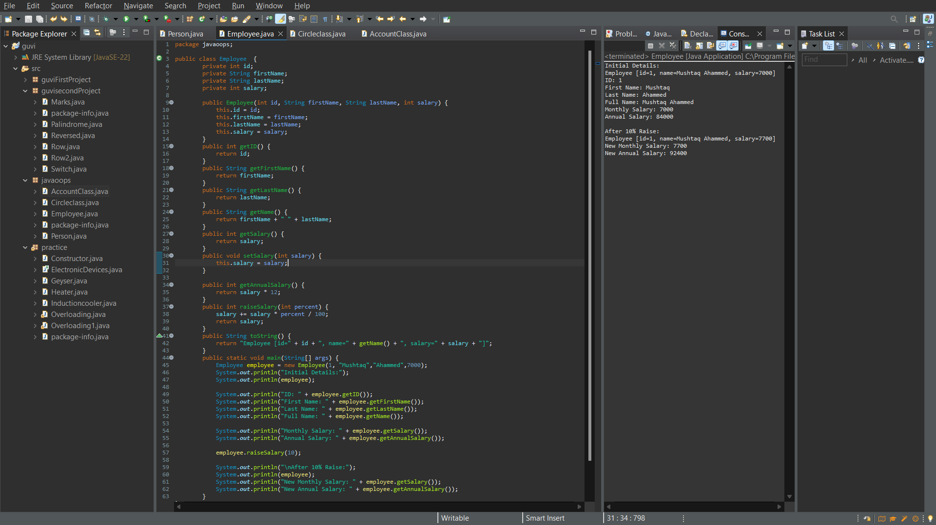

3. Create a class circle class with radius as data member. Create two constructors (no argument, and two arguments) and a method to calculate Circumference.

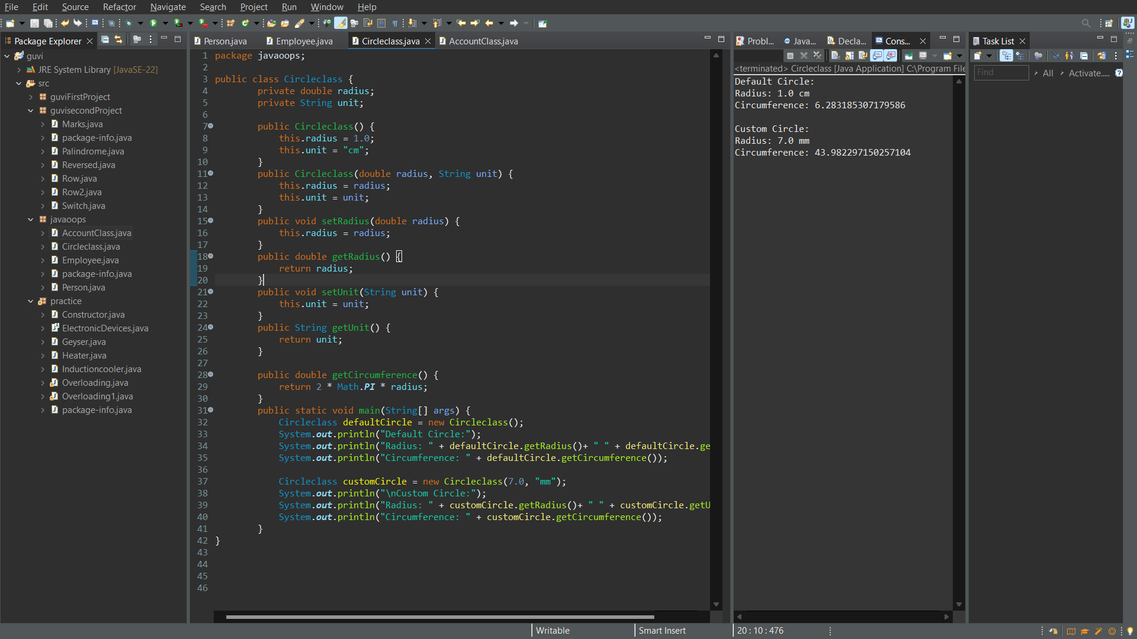

4. Create a class Account class with all necessary parameters as data member. Create two constructors (no argument, and two arguments) and methods to withdraw and deposit balance & check balanace.

